FOR IMMEDIATE RELEASE

Contact: Lynanne Schaeffer, Community Affairs Manager
Lschaeffer@gaudenzia.org or 215-205-1533

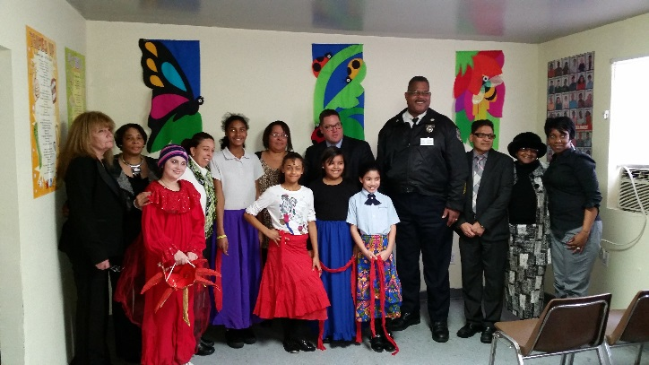
From left to right: Wendy Levin, Division Director-Gaudenzia; Gail Hannah, Deputy Regional Director-Gaudenzia; Leslie Acosta, PA State Representative; Child in the Program; Margie Inostrozia, Prevention Specialist-Gaudenzia; Richard Bauer, District Attorney’s Office; Carl Holmes, Chief Inspector-Philadelphia Police Department; Perry Patel, COO-Gaudenzia; Christine Abdur-Rahim, Division Director-Gaudenzia; Joy Martin, Division Director-Gaudenzia,
In Front: Children in the Program

Local Community Leaders Visit Gaudenzia’s Centro Primavera

Philadelphia, PA- February 17, 2016 – Community leaders from the Philadelphia area recently visited Centro Primavera to learn more about Gaudenzia's drug and alcohol prevention program for children. Among them were PA State Representative Leslie Acosta, Chief Inspector Carl Holmes of the Philadelphia Police Department, and Richard Bauer, Chief of the East Division, Philadelphia District Attorney’s Office.

The visit included a guided tour of the facility, a performance by the children, and a discussion about the history of the program and how it is impacting the community. After their performance, the children shared how Gaudenzia has helped them and what they like about the program.

About Centro Primavera

Serving children living in an impoverished, urban high-crime area, Centro Primavera began 28 years ago by parents concerned about increases in drug use in the neighborhood. Centro Primavera uses evidence-based programs to reduce risk among children ages 5-12. The programs provide prevention education to these high-risk children by teaching life skills and risk avoidance tools. Centro Primavera operates year-round, with in-school and after-school programs, in addition to summer camp. The after-school programs run in 12-week cycles, serving 20 children per cycle. During the summer, a 10 week camp is operated from 9 am-3 pm.

