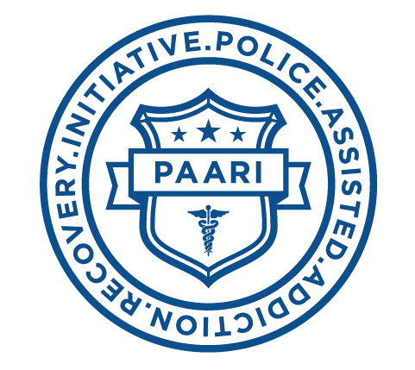

FOR IMMEDIATE RELEASE
Wednesday, June 23, 2016
Contact: John Guilfoil
Phone: 617-993-0003
Email: john@jgpr.net

Gaudenzia, Inc. Joins as P.A.A.R.I. Partner to Offer

Addiction Recovery Services to Participants

NORRISTOWN, Pa. -- Gloucester Police Chief Leonard Campanello and businessman John Rosenthal, co-founders of The Police Assisted Addiction Recovery Initiative (P.A.A.R.I.), are pleased to announce that Gaudenzia, Inc. has partnered with P.A.A.R.I. to offer addiction recovery services to program participants.
Last summer, Chief Campanello and Rosenthal launched P.A.A.R.I., a nonprofit organization created to support law enforcement agencies as they work with those suffering from addiction. Participating police departments place those who come to them for help into treatment programs, instead of jail. As P.A.A.R.I.'s partnerships with treatment facilities continue to grow, so does its ability to help police departments who want to assist their communities in saving lives.
"The number one war in America right now is drug addiction and it is killing the fiber of our communities," said Michael B. Harle, President and CEO of Gaudenzia. "It's not only our youth -- it's the middle-aged accountant, the housewife who suddenly had a dental problem and got hooked on opioids. Our work at Gaudenzia is about saving lives, and we are honored to partner with P.A.A.R.I. to continue that mission."
Gaudenzia, Inc. provides numerous addiction treatment and recovery services based on the Therapeutic Community model, including adult residential services, outpatient services, adolescent services, mental health residential services, prison services and both transitional and permanent housing. Clients and staff equally serve as agents of change with community being the guiding treatment approach. Individuals in treatment experience a structured schedule, learning behavioral tools and acquiring social skills to begin the path of drug-free, long-term recovery.
Chief Campanello and Rosenthal are eager to work with Gaudenzia and applaud them for taking the initiative to provide additional resources to P.A.A.R.I. participants.
About Gaudenzia, Inc.:
In 1968, in Philadelphia, a group of business, political, and community leaders, as well as those in recovery from drug and alcohol use, recognized a serious problem: a growing number of people affected by addiction were unable to find help. Gaudenzia was founded to help meet this need. Since then, it is estimated that Gaudenzia has admitted more than 200,000 individuals into treatment.
Today, the organization operates 147 programs at 76 facilities throughout Pennsylvania, Maryland and Delaware. Now serving more than 19,000 individuals annually, Gaudenzia operates residential and outpatient treatment programs, including specialty programs for pregnant and parenting women, individuals with HIV/AIDS, people coping with mental illness in addition to substance abuse issues, adolescents and more. Gaudenzia continues to improve and expand our services, helping individuals and their loved ones overcome the ravages of addiction to drugs and alcohol.
About P.A.A.R.I.:
P.A.A.R.I. was started to support local police departments as they work with those struggling with the disease of addiction. Rather than arrest our way out of the problem of drug addiction, P.A.A.R.I. committed police departments:
• Encourage opioid drug users to seek recovery
• Help distribute life-saving opioid blocking drugs to prevent and treat overdoses
• Connect people suffering with opioid addiction with treatment programs and facilities
• Provide resources to other police departments and communities that want to do more to fight the opioid addiction epidemic
P.A.A.R.I. was created by Gloucester Police Chief Leonard Campanello and John Rosenthal to bridge the gap between the police department and persons suffering from the disease of opioid addiction who are seeking recovery. Since its founding, more than 120 police departments in 24 states have joined as partners with the initiative.
# # #

